ASSIGNMENT 2 : Lexical Analysis

Q19. What is the role of a lexical analyzer generator like Lex?

At the most fundamental level, lexical analyzer generators like Lex and Flex represent a paradigm shift in how we approach compiler construction moving from imperative, hand-coded character processing to declarative, pattern-driven token recognition. This transformation addresses one of the most persistent challenges in compiler design: the reliable, efficient conversion of raw source code text into a structured stream of meaningful tokens that can be parsed according to grammatical rules. By allowing developers to express token definitions using the mathematical precision of regular expressions, these generators automate the translation of these specifications into optimized deterministic finite automata (DFA) implementations, complete with state transition tables, lookahead buffers, and error recovery mechanisms that would be extraordinarily difficult and error-prone to implement manually.
LEX is analyzer program for a given input string. It processes the given input string/file and transforms them into tokens. It is used by YACC programs to generate complete parsers. It reads the input stream and produces the source code as output through implementing the lexical analyzer in the C program. It can either be generated by NFA or DFA.
Lex is an acronym that stands for "lexical analyzer generator". It is intended primarily for Unix-based systems. It is easy, for example, the interface Flex lexical analyzer and Yacc, an open source program that generates code for the parser in the C programming language. The processing of character sequence such as source code to produce symbol sequence called tokens.
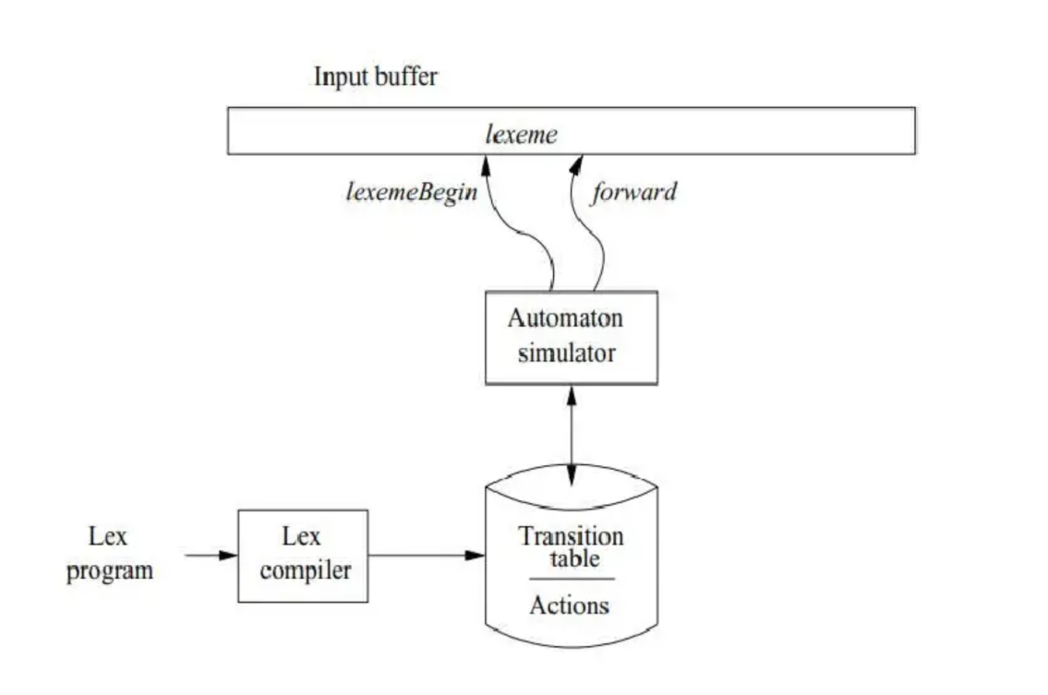
  - Structure of generated lexer.
The technical architecture of Lex-based systems reveals sophisticated engineering decisions that balance flexibility, performance, and usability. A Lex specification file, typically with a .l extension, employs a three-section structure that cleanly separates concerns: definition macros for pattern abbreviations, pattern-action rules where regular expressions pair with C code fragments, and user code for auxiliary functions. This structure teaches crucial software engineering lessons about separation of concerns and modular design. When Lex processes this specification, it performs multiple compilation phases internally: first translating regular expressions into nondeterministic finite automata (NFA) using Thompson's construction algorithm, then converting these to deterministic automata via subset construction, and finally applying table compression techniques like equivalence class partitioning to generate compact, efficient C code. The resulting scanner implements critical lexical analysis algorithms including the longest-match rule (selecting the maximal valid token at each position), rule priority resolution (choosing earlier rules for equal-length matches), and context handling through start conditions—all while maintaining linear O(n) time complexity through table-driven state transitions.
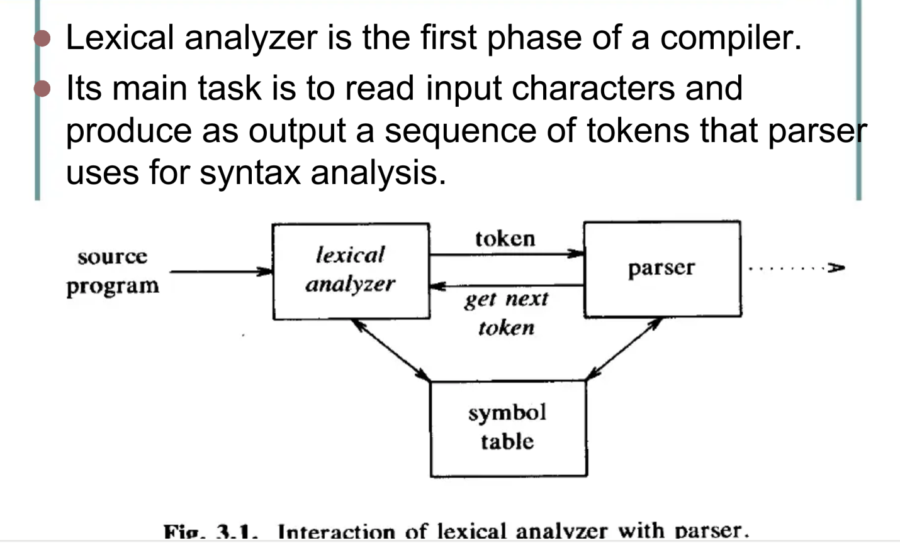
In the broader compiler ecosystem, Lex's true power emerges through its seamless integration with parser generators, particularly Yacc and its GNU counterpart Bison. This integration establishes a standardized communication protocol where the Lex-generated scanner (through the yylex() function) delivers token codes to the parser while using a shared yylval union to convey semantic values like numeric constants or string literals. This division of labor exemplifies the classic compiler architecture where lexical analysis handles character-level patterns while syntactic analysis manages grammatical structureyet maintains tight coupling through carefully designed interfaces. The practical implications are profound: developers can modify token definitions in the Lex specification without touching parser logic, and vice versa, enabling iterative language development. This modular approach has enabled countless programming languages, from early Unix utilities to modern domain-specific languages, to be prototyped and refined rapidly, accelerating language design experimentation and implementation.
Examining real-world applications reveals Lex's enduring relevance across computing domains. Traditional compiled languages like C, Pascal, and early C++ implementations used Lex-derived scanners in their front-ends. System utilities—from awk's pattern matching to make's dependency parsing—leverage Lex for processing configuration files and command syntax. Even in contemporary development, while direct Lex usage has diminished, its conceptual descendants power modern tools: ANTLR's lexer rules, Python's tokenize module, and JavaScript parser generators all employ the same fundamental pattern-action paradigm. Perhaps most tellingly, Lex's approach has influenced text processing far beyond compilers—network protocol parsers, data format validators, and log file analyzers all use similar generated scanners. This widespread adoption demonstrates how a compiler-specific technology can generalize to any domain requiring structured text recognition, proving the universality of its underlying principles.

Despite its age, Lex continues to offer unique educational value that makes it indispensable in compiler design curricula. Students implementing a Lex specification gain hands-on understanding of regular languages' expressive power and limitations—learning firsthand why regular expressions cannot count matched parentheses (requiring context-free grammars) or why certain lexical ambiguities require special handling. The generated code serves as a concrete example of table-driven versus direct-coded DFA implementations, illustrating important space-time tradeoffs. Furthermore, debugging Lex specifications teaches systematic problem-solving: tracing why a pattern fails to match, understanding precedence interactions, and learning to craft expressions that avoid catastrophic backtracking. These lessons transcend Lex itself, providing foundational knowledge applicable to any text processing tool or language implementation project students might encounter professionally.
Looking toward future developments, Lex's legacy persists in modern lexical analysis innovations while highlighting areas for continued advancement. Contemporary tools like re2c demonstrate how generated scanners can achieve near-optimal performance through aggressive optimization and direct machine code generation. Language workbench tools integrate lexical and syntactic analysis more tightly, offering better error recovery and incremental parsing capabilities. Cloud-based lexer generation services are emerging, allowing developers to specify token patterns through web interfaces with instant preview and collaboration features. Yet all these advances build upon Lex's core insight: that automatic code generation from declarative specifications dramatically improves productivity, reliability, and maintainability in compiler construction. As programming languages continue evolving with Unicode handling, internationalization requirements, and embedded domain-specific constructs the principles embodied in Lex remain essential: clean separation of lexical and syntactic concerns, mathematical foundations for pattern specification, and automated implementation of proven algorithms.
Ultimately, Lex and Flex represent more than just tools—they embody a philosophy of compiler construction that prioritizes declarative specification over imperative implementation, mathematical formalism over ad-hoc solutions, and automated generation over manual coding. Their enduring presence in both industrial compiler development and academic computer science education testifies to the soundness of their design and the universality of the problems they solve. By studying these tools, students and practitioners alike gain insight into one of computing's most successful applications of theory to practice: how abstract mathematical concepts (regular expressions, finite automata) translate directly into practical engineering solutions (efficient scanners, maintainable compilers). This bridge between theory and implementation lies at the very heart of compiler design, making Lex not merely a historical artifact but a living example of how elegant abstractions can solve complex engineering challenges across generations of computing technology.

